To Add your Club to the MAAA Database;

- Load the MAAA website http://www.maaa.asn.au/
- If you are not already a registered member – register your details
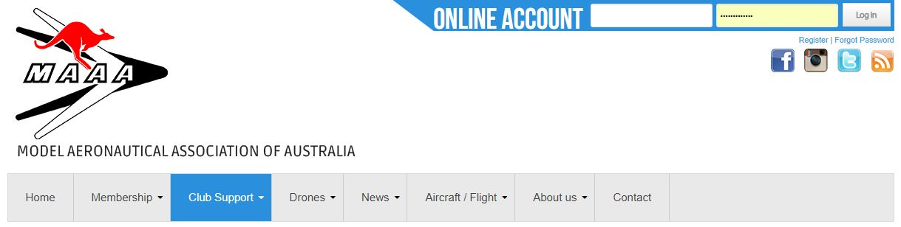

- Complete your details;

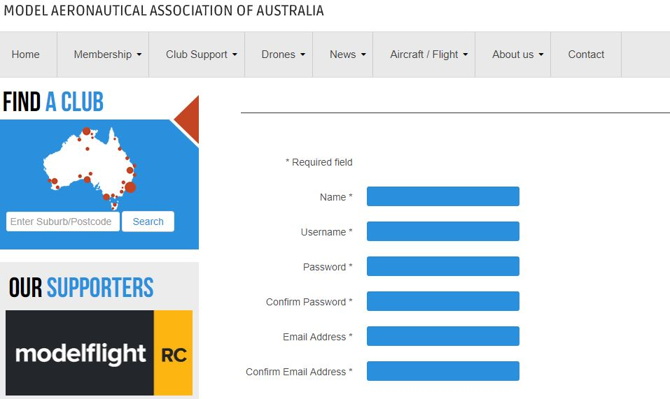

- Once registered login and go to ;

- Club Support and then Add a Club

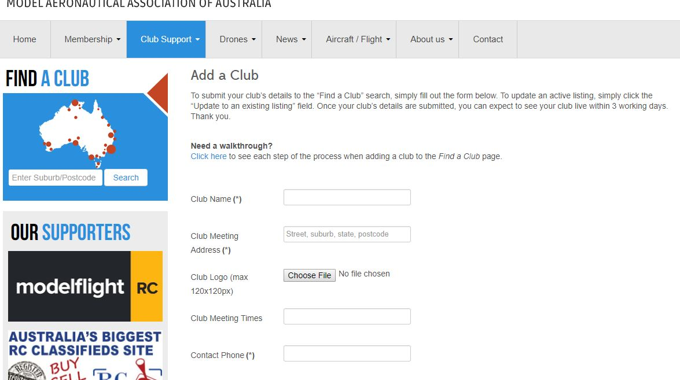

You Club will now display to anyone searching Clubs by using the MAAA Club Search website.

